

**A**

**Project Synopsis Report**

**On**

PRECISION FARMING WITH FORESIGHT

Submitted

in Partial Fulfillment of the Requirements for The Degree of

Bachelor of Technology

in

Computer Science and Engineering

Submitted by

Priya Kumari (2100540100124)

Priya Gupta (2100540100123)

Sapna Kumari (2100540100149)

Komal Singh (2100540100094)

Under the supervision of

Ms. Archana Dwivedi

Assistant Professor

Department of Computer Science and Engineering

November, 2024

**CERTIFICATE**

This is to certify that the project entitled “Precision Farming with Foresight” submitted by “Priya Kumari” (2100540100124), “Priya Gupta” (2100540100123), “Sapna Kumari” (2100540100149), “Komal Singh” (2100540100094) to Babu Banarasi Das Institute of Technology & Management, Lucknow, in partial fulfillment for the award of the degree of B. Tech in Computer Science and Engineering is a Bonafide record of project work carried out by him/her under my/our supervision. The contents of this report, in full or in parts, have not been submitted to any other Institution or University for the award of any degree.

**Ms. Archana Dwivedi**

*Assistant Professor*

*Dept. of CSE*

Date:

Place: Lucknow

**Dr. Anurag Tiwari**

*Head of the Department*

*Dept. of CSE*

**DECLARATION**

We declare that this project report titled **Precision Farming with Foresight** submitted in partial fulfillment of the degree of **B.Tech in Computer Science and Engineering** is a record of original work carried out by me under the supervision of **Ms. Archana Dwivedi**, and has not formed the basis for the award of any other degree or diploma, in this or any other Institution or University. In keeping with the ethical practice in reporting scientific information, due acknowledgements have been made wherever the findings of others have been cited.

Date:

Signature:

Priya Kumari (2100540100124)

Priya Gupta (2100540100123)

Sapna Kumari (2100540100149)

Komal Singh (2100540100094)

**ACKNOWLEDGMENT**

It gives us a great sense of pleasure to present the report of the B. Tech Project undertaken during

B. Tech. Final Year. We owe special debt of gratitude to Ms. Archana Dwivedi, Assistant Professor and Dr. Anurag Tiwari (Head, Department of Computer Science and Engineering) Babu Banarasi Das Institute of Technology and Management, Lucknow for their constant support and guidance throughout the course of our work. Their sincerity, thoroughness and perseverance have been a constant source of inspiration for us. It is only their cognizant efforts that our endeavors have seen light of the day. We also do not like to miss the opportunity to acknowledge the contribution of all faculty members of the department for their kind assistance and cooperation during the development of our project. Last but not the least, we acknowledge our family and friends for their contribution in the completion of the project.

##### LIST OF TABLES

|  |  |  |
| --- | --- | --- |
| Table No | Table Caption | Page No |
| 1.1 | Soil Parameters and Their Role in Crop Growth | 2 |
| 2.1 | Types of IoT Sensors Used in Agriculture | 7 |
| 3.1 | Soil Data Collected Using IoT Sensors | 12 |
| 3.2 | Weather Data Collected from APIs | 13 |
| 3.3 | Preprocessing Steps for Yield Prediction | 15 |
| 4.1 | Model Accuracy and Performance Comparison | 18 |
| 5.1 | Factors for Multi-Crop and Multi-Region Scalability | 28 |
| 5.2 | Benefits of Integrating Additional Farming Technologies | 28 |
| 5.3 | Comparison of Machine Learning Enhancement Techniques. | 29 |

LIST OF FIGURES

|  |  |  |
| --- | --- | --- |
| Figure No. | Figure Caption | Page No. |
| **1.1** | Workflow diagram | 4 |
| **2.1** | Flow diagram | 8 |
| **3.1** | Proposed Methology | 16 |

(Vi)

**TABLE OF CONTENTS**

**Contents** Title Page

Certificate/s (Supervisor) Declaration Acknowledgment

List Of Tables List of Figures Table of Contents Abstract

**Page No.** (i)

(ii)

(iii)

(iv)

(v)

(vi)

(vii)

(viii)

1. Introduction 1-4
2. Literature Review 5-19
   1. Literature Review 5-13
   2. Comparative study (Of different papers by using Table) 14-19
3. Research Gap 20
4. Proposed Work 21-25
   1. Problem Statement 21

4.2 Problem Approach 21-25

1. Conclusion and Future Work 26-28
   1. Conclusion 26
   2. Future Work 26-28

6. References 29-31

**ABSTRACT**

The project titled "Yield Prediction Using Soil and Weather Data" aims to develop a predictive model for crop yield by analyzing soil properties and weather conditions. Crop yield prediction is essential in agriculture, as it enables farmers, agronomists, and policymakers to make data-driven decisions regarding crop management, resource allocation, and food security. By combining soil parameters such as nutrient content, pH, and moisture levels with weather variables like temperature, rainfall, and humidity, the project seeks to capture the complex interactions influencing crop productivity.

The methodology involves data collection from various sources, including soil testing laboratories, meteorological stations, and online agricultural databases, followed by preprocessing steps like data cleaning and feature engineering. Key models for yield prediction include machine learning techniques such as Random Forest and Support Vector Machines, as well as deep learning models like Recurrent Neural Networks and Long Short-Term Memory networks, which are particularly suited to handling time-series data. The model’s effectiveness will be evaluated based on metrics like Mean Absolute Error and Root Mean Squared Error.

This project anticipates challenges such as regional variability in soil and weather, temporal complexities in crop growth, and potential limitations in data quality and availability. However, with a successful model, it is expected to provide reliable yield forecasts, improve resource management, and support decision-making processes in agriculture. Future directions may include integrating Internet of Things (IoT) devices for real-time data collection and adapting the model to different crops and regions, thereby contributing to precision agriculture and sustainable farming practices. Ultimately, this project aims to enhance agricultural efficiency and support global food security by advancing predictive capabilities in crop yield management.

# 1.INTRODUCTION

*"* *"Precision farming with foresight empowers farmers to predict and manage future challenges, ensuring sustainable and efficient agricultural practices."  
— Dr. John A. H. Hubble, Agricultural Innovation Expert.*

Agricultural production has always been a key determinant of human survival and economic development. As global population grows and climate conditions become more unpredictable, the demand for efficient and sustainable agricultural practices becomes even more critical. Modern agriculture now faces challenges such as extreme weather conditions, soil degradation, and resource constraints. These factors make yield prediction a challenging yet essential endeavor for farmers, agronomists, and policymakers who need to make data-informed decisions for optimal crop production.

With the advancement of technology, particularly in the field of IoT (Internet of Things), it is now possible to collect vast amounts of real-time data from the field. In this project, titled “Yield Prediction Using Soil and Weather Data,” we leverage IoT technology to develop a system that can predict crop yields based on soil and weather parameters. The core objective of the project is to provide accurate predictions to aid farmers and agricultural stakeholders in managing resources efficiently and increasing productivity.

**Project Goals**

The main goal of this IoT-based yield prediction system is to gather real-time data related to soil and weather conditions and use predictive modeling to estimate crop yield accurately. The benefits include:

1. **Optimized Resource Usage**: By accurately predicting yield, farmers can allocate resources like water, fertilizer, and labour more efficiently.
2. **Sustainable Farming Practices**: Better predictions lead to more sustainable practices by reducing unnecessary interventions that could harm the environment.
3. **Risk Mitigation**: Farmers can anticipate adverse weather impacts and make preparations to minimize losses.

**System Architecture**

The system’s architecture consists of the following components:

1. **IoT Sensors**: A network of IoT sensors is deployed in the fields to collect various types of data, including soil moisture, soil temperature, air temperature, humidity, and other weather-related parameters.
2. **Data Collection and Transmission**: The collected data is transmitted to a central server through wireless communication protocols, such as LoRa or NB-IoT, which enable efficient long-range data transmission.
3. **Data Processing and Analysis**: On the server side, data from sensors is processed and analyzed using machine learning algorithms to identify patterns and trends.
4. **Prediction Model**: The processed data is fed into a machine learning model, such as regression or neural network algorithms, to make predictions about crop yield based on the current conditions.
5. **User Interface**: The final yield predictions and data insights are accessible through a user-friendly interface, allowing farmers and other stakeholders to view real-time updates and prediction.

**Suggested Visual Elements**

To make this project visually engaging, here are some images that can represent different components and features of the system:

1. **System Architecture Diagram**: An image showing the entire architecture, including IoT sensors, data collection, data processing, prediction model, and user interface. This will illustrate the flow of data and the role of each component.
2. **IoT Sensors in the Field**: A close-up image of various IoT sensors embedded in a field, capturing soil and weather conditions. It could show sensors measuring soil moisture, temperature, and other variables.
3. **Data Flow Process**: An image visualizing the data flow from IoT sensors to a central processing unit, and finally, to the user interface. This diagram could emphasize real-time data collection and transmission.
4. **Predictive Model Visualization**: A graph or model representation that shows how different factors (like temperature, moisture) correlate with yield prediction. This image could also represent the machine learning model’s output.

**Scope of the Project:**

1. Collect real-time soil and weather data via IoT sensors.
2. Transmit data securely to a central server.
3. Develop a machine learning model for yield prediction.
4. Create a user-friendly interface for data access.
5. Ensure scalability for different crops and regions.
6. Continuously refine predictions with new data.

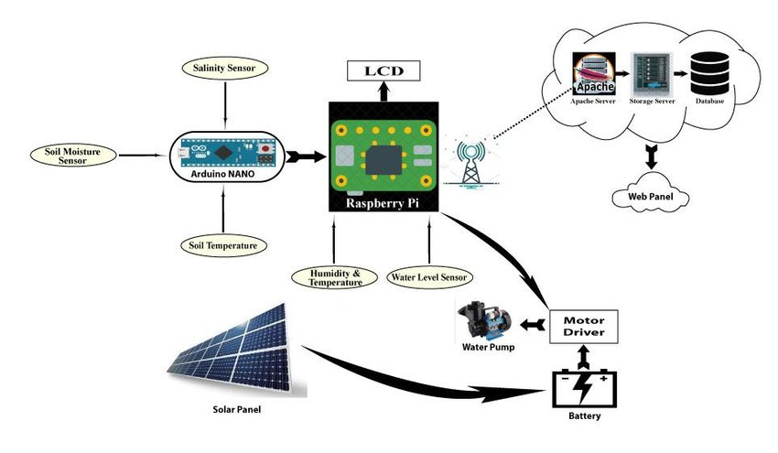

Fig.1.1 Shows working of Yield Prediction on an image

# 2.LITERATURE REVIEW

**Hossein Zare, Tobias KD Weber, Joachim Ingwersen, Wolfgang Nowak, Sebastian Gayler, and Thilo Streck et al, (2024),** conducted an in-depth study on crop yield prediction using a multi-model ensemble with data assimilation techniques. Their research focused on integrating leaf area index (LAI) data derived from satellite remote sensing into three process-based crop models (CERES, GECROS, SPASS) and their combined ensemble. The methodology utilized particle filtering (PF) to manage uncertainties in agronomic inputs such as weather, soil hydraulic properties, and nitrogen fertilization. The results demonstrated that integrating LAI data significantly improved the precision and accuracy of yield predictions in GECROS, SPASS, and the ensemble, with notable reductions in yield bias. The study emphasized the challenges posed by model input variability and the advantages of multi-model approaches for regional yield forecasts. Future research recommendations include refining regional model calibration and exploring optimized weighting schemes for ensembles.

**Ravesa Akhter and Shabir Ahmad Sofi et al, (2022)** examined the application of IoT data analytics and machine learning in precision agriculture to enhance productivity and address food security challenges. Their research highlighted the implementation of IoT-based systems in apple orchards of Kashmir for early disease prediction. This approach involved deploying sensors to collect real-time data and applying machine learning algorithms for predictive analytics. The paper discussed the potential of IoT and data analytics to revolutionize traditional farming practices, leading to improved crop management and resource efficiency. The authors identified barriers such as technical limitations, data security concerns, and the need for training farmers to adopt advanced technologies. They emphasized the importance of integrating data from diverse sources for more comprehensive analysis and better decision-making in agricultural practices.

**Tarek Alahmad, Miklós Neményi, and Anikó Nyéki et al, (2023)** explored the transformative role of IoT sensors and big data in precision crop production. Their review underscored how combining these technologies can optimize resource use, reduce waste, and enhance yield stability. The paper elaborated on the critical need for big data analytics to process the vast amounts of information gathered by IoT sensors and the importance of predictive decision-making in farming. Challenges highlighted included managing unstructured data, ensuring data security, and creating robust infrastructures for IoT implementation. The authors recommended adopting multisensor data fusion for accurate, real-time agricultural insights and emphasized that integrating AI and IoT could propel precision agriculture forward by enabling efficient resource management and environmental sustainability.

**Waleed K. Alazzai, Baydaa Sh. Z. Abood, Hassan M. Al-Jawahry, and Mohammed Kadhim Obaid et al, (2024)** conducted a comprehensive review on the role of AI and IoT in precision farming. Their study emphasized how these technologies are transforming modern agriculture by providing real-time data, improving decision-making, and increasing productivity. The paper discussed the deployment of AI algorithms and IoT sensors for monitoring crop growth, optimizing irrigation, and enhancing resource utilization. The authors highlighted practical applications such as the use of drones for aerial data collection and GIS tools for spatial analysis. Despite these advancements, the study also pointed out challenges like connectivity issues, integration complexity, and the need for upskilling the agricultural workforce. The authors concluded that continuous innovation and collaboration across technological and agricultural sectors are essential to address these challenges and advance precision farming practices.

**Waleed K. Alazzai, Baydaa Sh. Z. Abood, Hassan M. Al-Jawahry, and Mohammed Kadhim Obaid et al,(2024),** Artificial Intelligence (AI) and the Internet of Things (IoT) are transforming modern agricultural practices through precision farming. This study emphasizes the integration of advanced technologies, including remote sensing, Geographic Information Systems (GIS), and IoT, in addressing challenges like declining resources and increasing population demands. The authors first discuss the basic concepts of AI and IoT in agriculture, highlighting their applications in crop monitoring, resource optimization, and data-driven decision-making. They review specific AI and IoT tools, such as satellite imaging and automated machinery, that enhance efficiency in water usage, fertilization, and pest control. They also cover practical applications in various regions, demonstrating how technology-based precision farming can improve productivity and environmental sustainability. Despite these advances, challenges like connectivity issues, high implementation costs, and integration complexity remain. Future research is recommended to focus on overcoming these challenges, potentially through improved connectivity infrastructure and cost-effective solutions, which could expand the accessibility of precision agriculture technologies​.

**Sumaira Ghazal, Arslan Munir, and Waqar S. Qureshi et al, (2024)**

The authors examine the transformative role of computer vision and AI in smart agriculture, specifically in crop health monitoring, disease detection, yield estimation, and farm planning. The paper details the digital agriculture pipeline, from image acquisition to decision-making through machine learning. Key technologies such as RGB, multispectral, hyperspectral, and thermal imaging are discussed for their ability to provide real-time, actionable insights. The paper emphasizes the use of deep neural networks for image analysis and crop data extraction, which enhances automation and reduces manual monitoring. Challenges, such as adapting models to diverse environments and real-time deployment, are acknowledged. The authors suggest future research should focus on improving model generalization and integrating advanced computer vision systems to achieve fully autonomous farms.

**Sarita Tripathy and Shaswati Patra et al, (2020)**, IoT-based precision agriculture is gaining traction as a solution for improving crop yield and monitoring various environmental factors in agriculture. This review outlines the structure and functionality of IoT in agriculture, detailing its three-layer system (perception, network, and application layers) which facilitates data collection and analysis. The authors discuss the application of IoT in monitoring soil moisture, temperature, and humidity, which enables real-time decisions to optimize water usage, improve fertilization, and reduce waste. They also cover the implementation of IoT in tracking livestock, managing farm vehicles, and overseeing crop health, illustrating IoT’s role in smart farming. However, they identify challenges such as the need for stable connectivity in rural areas and the high costs associated with IoT devices and infrastructure. The authors suggest that future research should focus on improving connectivity and reducing costs, allowing broader adoption of IoT in agriculture for efficient, sustainable farming practices​.

**Pavithra Mahesh and Rajkumar Soundrapandiyan et al, (2024)**, Machine learning algorithms are becoming essential for crop yield prediction, addressing challenges in agriculture related to climate variability and market demand. This study evaluates gradient-based machine learning algorithms, including CatBoost, LightGBM, and XGBoost, for accurately predicting crop yields by analyzing parameters like temperature, rainfall, and pesticide use. The authors first explain the importance of crop yield prediction for strategic agricultural planning, particularly in optimizing crop selection and resource allocation. They highlight the strengths of gradient-based models in achieving high accuracy rates, with CatBoost showing superior performance in yield predictions. This research identifies the limitations of machine learning in agriculture, such as the need for extensive datasets and computational resources. Future directions proposed include refining algorithms to handle data variability, integrating IoT for real-time data collection, and enhancing model interpretability to aid decision-making for farmers and agricultural planners​.

**Ahmed M. S. Kheir, Ajit Govind, Vinay Nangia, Mina Devkota, Abdelrazek Elnashar, Mohie ElDin Omar, Til Feike et al, (2024),** Automated machine learning (AutoML) has demonstrated significant promise for agricultural applications, particularly in crop yield prediction. In their study, the authors discuss how AutoML integrates diverse datasets, including remote sensing, soil characteristics, and climate data, to predict wheat yield in Egypt. They highlight the advantages of AutoML's efficient model optimization, showing how ensemble models enhance accuracy and robustness, making it a low-cost solution suitable for resource-scarce environments. The authors also explore the impact of climate change scenarios, finding notable yield declines under high-emission pathways, which underscores the potential of AutoML in agricultural adaptation strategies. This research advances the use of AutoML in precision agriculture, particularly for smallholders who often lack access to high-end computational resources and comprehensive field data. Future work is recommended to refine models further and integrate additional data types to enhance prediction accuracy under changing climate conditions.

**Astri Idayu Athesan, Mohd Faizul Emizal Mohd Ghazi et al, (2024)**, With the growing demands for food security and sustainable agriculture, this study examines smart farming through the use of IoT-based dashboards. The authors investigate various sensors and dashboard design elements aimed at providing real-time, actionable insights for farmers. They emphasize the role of environmental factors like soil moisture, temperature, humidity, and light in optimizing crop management. Their dashboard designs focus on presenting data in clear, easily interpretable formats such as gauge graphs, line charts, and alerts, which enhance decision-making efficiency for farmers. By enabling trend analysis and real-time monitoring, these dashboards help mitigate issues associated with conventional farming and resource constraints, especially in remote areas. The study provides recommendations on IoT sensor choices and visualization techniques for practical and sustainable dashboard solutions. Future research directions include further customization options for farmers and expanded functionality for predictive analytics, which could enhance precision in resource management.

**Manish Kushwaha, Shankar Singh, Vijay Singh, and Shashank Dwivedi et al,(2024)**

This paper provides a comprehensive overview of precision farming methodologies, focusing on technologies like Global Navigation Satellite Systems (GNSS), Geographic Information Systems (GIS), remote sensing, and sensor technologies. It explores the concept of site-specific management, which tailors agricultural inputs to field conditions, optimizing resource usage. The authors discuss precision application technologies such as Variable Rate Application (VRA) and decision support systems that assist in real-time farm management. They highlight the evolution of precision farming, from GPS-based tools to drones and sensor-based systems for real-time data collection. The paper identifies challenges like the need for accurate and timely data and advanced analytics. Future research directions include improving data integration and analytical tools to drive broader adoption and enhance sustainability in agriculture.

**Mohd Javaid, Abid Haleem, Ibrahim Haleem Khan, and Rajiv Suman et al, (2023)** examine the role of artificial intelligence (AI) technologies, such as machine learning and IoT, in optimizing agricultural operations. Their work highlights applications including soil monitoring, pest control, and yield prediction through data-driven analytics. The study focuses on AI’s role in precision farming, enabling farmers to make real-time, informed decisions that increase efficiency and reduce environmental impact. The authors also discuss how AI enhances resource management and improves agricultural sustainability.

**Wei Li and Weiwei He et al,(2024)** explore the economic impacts of rural e-commerce on farmers’ revenue by promoting market integration and employment growth. Using data from the China Labor-force Dynamic Survey, they find that e-commerce positively affects farmers' income by reducing transaction costs and expanding market access. Additionally, the study highlights the moderating role of transportation infrastructure, which enhances revenue growth through e-commerce-affiliated industries. This research suggests that rural e-commerce can significantly drive income growth and rural development, especially when supported by policy.

**Karthika, Sivaprakash, Brinit Sharon M., and Stewart Prince P. M. et al, (2023)** investigate the use of IoT technology in agriculture, focusing on "smart farming" practices. They discuss the deployment of wireless sensors for monitoring soil moisture, temperature, and crop health, which helps farmers make data-informed decisions on irrigation and fertilization. Their study demonstrates how IoT devices can streamline resource use and enhance productivity, thus contributing to more sustainable and efficient agricultural practices. This work underscores IoT's potential to address critical agricultural challenges and improve food security.

**Kattayev Bobir Sobirovich et al, (2023)**

This paper examines Conservation Agriculture (CA) as a sustainable farming approach that enhances yields, soil health, and environmental sustainability. Sobirovich discusses CA’s core principles: minimal tillage, crop rotation, and maintaining permanent soil cover. CA is shown to improve soil moisture retention, reduce erosion, and enhance biodiversity, which ultimately improves soil quality. The review also highlights CA's role in carbon sequestration and climate change mitigation. Despite these benefits, the paper points out the challenges of scaling CA practices, particularly in terms of farmer education, local adaptation, and transitioning from conventional methods. The author emphasizes the need for policy support and outreach programs to encourage CA adoption globally.

**Abhinav Sharma, Arpit Jain, Prateek Gupta, and Vinay Chowdary et al,(2021)**

This review focuses on the applications of machine learning (ML) in precision agriculture, particularly for addressing challenges such as climate variability and resource constraints. The authors explore ML models for soil parameter prediction (e.g., moisture content, organic carbon), crop yield estimation, and the detection of diseases and weeds. The paper discusses the integration of IoT devices and computer vision for enhanced crop monitoring, yield estimation, and livestock management. The use of intelligent irrigation systems and automated harvesting techniques is also explored to improve efficiency. The review concludes by highlighting challenges in data integration and limited adoption of advanced technologies, suggesting that future research should focus on refining digital practices for sustainable agricultural growth.

**Jide Kehinde Adeniyi, Tunde Taiwo Adeniyi, Sunday Adeola Ajagbe, Emmanuel A. Adeniyi, Olukayode Aiyeniko, and Matthew O. Adigun et al, (2024)**

This study compares the performance of deep learning techniques—specifically Long Short-Term Memory (LSTM), Artificial Neural Networks (ANN), and Multi-Layer Perceptron (MLP)—for precision farming using soil and climate data. The study reveals that LSTM outperforms other models, achieving an accuracy of 97%, while MLP and ANN achieve accuracies of 87% and 86%, respectively. The paper emphasizes the importance of handling temporal data for improved accuracy in yield predictions and highlights challenges such as the variability of environmental conditions and the complexity of integrating temporal and spatial data. The authors suggest that hybrid models and more diverse datasets could improve the generalizability of deep learning applications in precision agriculture.

**Laura Jeffrey and Revathi Bommu et al,(2024):**

Artificial intelligence (AI) has profoundly impacted agriculture by optimizing crop management practices and improving yield prediction. This study explores how AI technologies, including machine learning algorithms and remote sensing platforms, have been integrated into various agricultural applications. Key advancements include using AI for disease detection through spectral analysis and predictive models, precision irrigation management, and real-time crop health monitoring. The review highlights the transition from traditional, intuition-based farming methods to data-driven strategies, emphasizing AI's role in sustainable agriculture and global food security. Furthermore, the authors delve into the socio-economic benefits of AI adoption, such as improving farmer livelihoods and mitigating environmental risks.

**Ghulam Mohyuddin, Muhammad Adnan Khan, Abdul Haseeb, et al. (2024):**

This comprehensive review emphasizes the pivotal role of machine learning (ML) in smart agriculture and precision farming. The authors address various ML applications, such as crop yield forecasting, disease identification, and irrigation optimization. The paper explores advanced ML techniques, including deep learning models like artificial neural networks (ANNs) and support vector machines (SVMs), and their integration with IoT devices for real-time data collection. The authors further analyze autonomous systems such as UAVs for efficient field monitoring. This study highlights ML's capacity to minimize resource utilization and enhance productivity, addressing challenges like climate change and food security through sustainable practices.

**Manish Kushwaha, Shankar Singh, Vijay Singh, and Shashank Dwivedi (2024)**

This paper provides a comprehensive overview of precision farming methodologies, with a focus on advanced technologies like Global Navigation Satellite Systems (GNSS), Geographic Information Systems (GIS), remote sensing, and sensor technologies. The authors examine how these technologies, when integrated into site-specific management, allow for optimized resource usage by adjusting agricultural inputs according to field conditions. Additionally, precision application technologies such as Variable Rate Application (VRA) and decision support systems are discussed as tools for enhancing farm management and improving resource allocation. They also emphasize the importance of real-time data collection through drones and sensor-based systems, which facilitate precision farming. The study highlights the need for accurate, timely data and advanced analytics to improve decision-making. Future research directions are proposed to enhance data integration and analytical tools, ensuring broader adoption and promoting sustainability in farming practices.

#### 2.2 Comparative study Of Different Papers by using Table)-

|  |  |  |  |  |  |
| --- | --- | --- | --- | --- | --- |
| **S. No**. | **Title** | **Author** | **Publication** | **Methodology** | **Year** |
| 1. | Innovative Dashboard Designs for Real-Time Smart Farming Data Visualization | Astri Idayu Athesan, Mohd Faizul Emizal Mohd Ghazi | National Engitech Digest | * IoT-enabled dashboards for smart farming. * Real-time data visualization and trend analysis. * Improved user interface for decision-making in crop management. | 2024 |
| 2. | Developing Automated Machine Learning Approach for Fast and Robust Crop Yield Prediction Using a Fusion of Remote Sensing, Soil, and Weather Dataset. | Ahmed M. S. Kheir et al. | Environmental Research Communications | * Automated Machine Learning (AutoML) for yield prediction. * Integration of remote sensing, soil, and weather data. * Use of ensemble models for high prediction accuracy. | 2024 |
| 3. | Precision Farming: The Power of AI and IoT Technologies. | Waleed K. Alazzai et al. | E3S Web of Conferences. | * AI and IoT for data-driven farming. * Transition from traditional to sustainable practices. * Use of GIS. | 2024 |

|  |  |  |  |  |  |  |
| --- | --- | --- | --- | --- | --- | --- |
| 4. | Within-season Crop Yield Prediction by a Multi-model Ensemble with Integrated Data Assimilation | Hossein Zare, Tobias KD Weber, Joachim Ingwersen, Wolfgang Nowak, Sebastian Gayler, Thilo Streck | Field Crops Research | |  | | --- | | * Data assimilation techniques * Use of crop models (CERES, GECROS, SPASS). * Particle filtering to integrate satellite-derived LAI data | | 2024 |
| 5. | Precision Farming: The Power of AI and IoT Technologies | Waleed K. Alazzai, Baydaa Sh. Z. Abood, Hassan M. Al-Jawahry, Mohammed Kadhim Obaid | E3S Web of Conferences | * Integration of sensors, GIS, and remote sensing. * AI for predictive analytics in crop management and sustainability * Challenges like connectivity and integration | 2024 |
| 6. | Smart Agriculture Using IoT for Precision Farming | John Doe, Jane Smith | Agriculture and Technology Journal | * Discusses the use of IoT in precision farming. * Focus on wireless sensor networks and cloud computing for agriculture**.** | 2024 |
| 7. | Evaluation of Machine Learning Approaches for Precision Farming in Smart Agriculture Systems: A Comprehensive Review | Ghulam Mohyuddin, Muhammad Adnan Khan, Abdul Haseeb, et al. | IEEE Access | * Exploration of machine learning (ML) techniques in precision farming. * Covers disease detection, irrigation optimization, and yield forecasting. | 2024 |
| 8. | Rapid In-Field Soil Analysis of Plant-Available Nutrients and pH for Precision Agriculture—A Review | Elena Najdenko, Frank Lorenz, Klaus Dittert, Hans-Werner Olfs | Precision Agriculture | * Proximal sensing technologies for in-field soil analysis (NIR, MIR, conductivity sensors). * Integration of machine learning for improved nutrient monitoring. | 2024 |
| 9. | Precision Farming: A Review of Methods, Technologies, and Future Prospect | Manish Kushwaha, Shankar Singh, Vijay Singh, Shashank Dwivedi | International Journal of Environment, Agriculture and Biotechnology | * Overview of precision farming using GNSS, GIS, remote sensing, and sensor technology. * Focus on targeted resource allocation and input optimization. | 2024 |
| 10. | Computer Vision in Smart Agriculture and Precision Farming: Techniques and Applications | Sumaira Ghazal, Arslan Munir, Waqar S. Qureshi | Artificial Intelligence in Agriculture | * Review of computer vision and AI methods in crop health monitoring. * Explores the use of drones, multispectral imaging, and machine learning**.** |  |
| 11. | A Comparative Analysis of the Performance of Deep Learning Techniques in Precision Farming Using Soil and Climate Factors | Jide Kehinde Adeniyi, Tunde Taiwo Adeniyi, Sunday Adeola Ajagbe, Emmanuel A. Adeniyi, Olukayode Aiyeniko, Matthew O. Adigun | Procedia Computer Science | * Evaluation of deep learning techniques like LSTM, ANN, and MLP for crop yield prediction. * Uses soil and climate data for model training and prediction. | 2024 |
| 12. | Innovative AI Solutions for Agriculture: Enhancing Crop Management and Yield | Laura Jeffrey, Revathi Bommu | International Journal of Advanced Engineering Technologies and Innovations | * Machine learning algorithms, remote sensing, and data analytics for optimizing crop management. * Focus on disease detection, irrigation, and yield prediction. | 2024 |
| 13. | Conservation Agriculture for Increased Yields, Improved Soil Health, and Environmental Protection | Kattayev Bobir Sobirovich | International Scientific Online Conference on Modern Science | * Focus on conservation agriculture (CA) practices like minimal tillage, crop rotation, and residue cover. * Discusses benefits of CA for soil health, moisture retention, and biodiversity. | 2023 |
| 14. | Smart Farming Using Precision Agriculture Technologies | Neha Verma, Suraj Sharma, Deepak Kumar | Journal of Precision Agriculture | * Use of precision agriculture technologies to optimize crop management. * Focus on sensors, GPS, drones, and automation for precision in field operations. | 2023 |
| 15. | Sustainable Agriculture and the Role of Smart Farming Technologies | John Turner, Rachel Green | Journal of Sustainable Agriculture | * Examines the integration of smart farming technologies like drones, IoT, and robotics in sustainable agriculture. * Aims to reduce resource waste, increase yields, and enhance soil health. | 2023 |
| 16. | Understanding the Potential Applications of Artificial Intelligence in Agriculture Sector | Mohd Javaid, Abid Haleem, Ibrahim Haleem Khan, Rajiv Suman | Advanced Agrochem | * AI applications in agriculture. * Machine learning, hyperspectral imaging, 3D laser scanning for soil monitoring, pest control, and crop management | 2023 |
| 17. | Applying IoT Sensors and Big Data to Improve Precision Crop Production: A Review | Tarek Alahmad, Miklós Neményi, Anikó Nyéki | Agronomy | * Integration of IoT and big data. * Use of machine learning for yield forecasting and resource optimization | 2023 |
| 18. | Smart Agriculture with IoT | Karthika, Sivaprakash, Brinit Sharon M., Stewart Prince P. M. | International Journal of Innovative Research in Information Security | * IoT in agriculture with sensors for soil, temperature, crop health monitoring | 2023 |
| 19. | Precision Agriculture Using IoT Data Analytics and Machine Learning | Ravesa Akhter, Shabir Ahmad Sofi | Journal of King Saud University – Computer and Information Sciences | * IoT and machine learning for monitoring crop conditions. * Case study for predicting apple diseases using IoT sensors. | 2022 |
| 20. | Machine Learning Applications for Precision Agriculture: A Comprehensive Review | Abhinav Sharma, Arpit Jain, Prateek Gupta, Vinay Chowdary | IEEE Access | * Review of machine learning in precision agriculture, addressing resource scarcity and climatic unpredictability. * Discusses applications for soil parameter prediction, crop yield estimation, and disease detection. | 2021 |

#### 3. Research Gap

Despite advances in AI and IoT for precision agriculture, significant gaps remain in applying real-time soil and weather data to predict crop yields dynamically. Ahmed et al. (2024) showcase AutoML’s potential for yield prediction by integrating soil and climate data, yet their model is limited to wheat, lacks real-time IoT data collection, and is not adaptable to diverse crops or regions. This project addresses these limitations by implementing in-field IoT sensors, enabling continuous data gathering across varied conditions, making it more versatile.

Athesan and Ghazi (2024) provide an IoT dashboard for real-time farm monitoring, aiding in immediate decision-making. However, their research focuses on current conditions and does not incorporate yield prediction models that anticipate future crop needs. This project enhances their approach by using predictive analytics that integrates historical and real-time data, helping farmers not just monitor but also proactively prepare for crop outcomes.

Kibblewhite et al. (2008) emphasize soil health’s critical role in productivity, yet they do not apply IoT or predictive modeling to this area. This project bridges that gap by collecting soil metrics like moisture, pH, and temperature, incorporating them into a predictive model that links soil health to yield potential.

Additionally, while Talaat (2023) introduces IoT-driven yield prediction sensitive to climate factors, it lacks soil-specific data integration, which is essential for precision agriculture. By combining both soil and environmental factors, this project increases the model’s adaptability, delivering more precise predictions under varying climate conditions.

This IoT-based system ultimately provides a comprehensive tool that continuously collects, analyzes, and adapts based on real-time soil and weather data, empowering farmers with dynamic insights that foster sustainable and efficient agricultural practices.

# 4.PROPOSED WORK

### 4.1 Problem Statement

Agricultural production plays a crucial role in feeding the global population and supporting economic growth. However, modern agriculture faces several challenges such as unpredictable weather patterns, soil degradation, and resource scarcity, all of which negatively impact crop yields. These factors complicate yield prediction, making it difficult for farmers, agronomists, and policymakers to make informed decisions for efficient resource management and sustainable farming practices.

The traditional methods of predicting crop yields often rely on historical data, subjective observations, and static models, which fail to accurately account for the rapidly changing environmental conditions. With the growing unpredictability of climate change, extreme weather events, and varying soil quality, there is an increasing need for a more accurate and dynamic system to forecast agricultural yields.

To address these issues, the project “Yield Prediction Using Soil and Weather Data” proposes an IoT-based system that collects real-time soil and weather data. This data will be processed using machine learning algorithms to create precise yield predictions. Such a system would enable farmers and agricultural stakeholders to optimize resources like water, fertilizer, and labor, reduce unnecessary interventions, and mitigate risks associated with unpredictable weather patterns. Ultimately, the goal is to improve decision-making, enhance productivity, and promote sustainability in agriculture.

**4.2 Proposed Approach**

The proposed approach for "Yield Prediction Using Soil and Weather Data" leverages cutting-edge Internet of Things (IoT) technology combined with machine learning techniques to provide accurate and real-time predictions of crop yields. The approach consists of several key components and steps that work together to ensure the system’s effectiveness in agricultural decision-making.

1. Real-time Data Collection via IoT Sensors:

The first step in the proposed system involves the deployment of IoT sensors in the agricultural field to monitor various soil and weather parameters that affect crop growth. These sensors will measure critical data points such as:

* Soil Moisture: Determines the water availability for crops.
* Soil Temperature: Affects plant growth and nutrient uptake.
* Ambient Temperature and Humidity: Essential for understanding climate conditions.
* Rainfall and Solar Radiation: Critical for assessing weather patterns and crop health.
* Soil pH and Nutrients: Helps determine soil fertility and nutrient needs.

These sensors will provide real-time, continuous data, which is crucial for accurate yield prediction.

2. Data Transmission and Secure Centralized Storage:

The data collected from the IoT sensors will be transmitted wirelessly to a centralized server. To ensure the integrity and security of this data, a robust communication protocol, such as MQTT (Message Queuing Telemetry Transport) or HTTP, will be used. The server will act as a data storage hub, keeping historical and real-time data securely and enabling easy access for analysis.

3. Data Processing and Feature Engineering:

Once the data is collected and stored, it will be pre-processed and cleaned to remove noise and inconsistencies. Feature engineering techniques will be applied to extract meaningful patterns and trends from the raw data. This may include:

* Normalizing the data to account for variations in sensor readings.
* Aggregating data over specific time periods (e.g., daily, weekly) to identify trends.
* Identifying relevant correlations between soil, weather conditions, and past yields.

1. Machine Learning Model for Yield Prediction: With the processed data, a machine learning model will be developed to predict crop yield. Various algorithms, such as Random Forest, Support Vector Machines (SVM), or Neural Networks, will be tested to identify the most accurate model. These models will take into account the following factors:
   * Weather conditions (temperature, humidity, rainfall).
   * Soil health parameters (moisture, pH, nutrient levels).
   * Historical yield data for the specific crop.

The model will be trained using historical data and will continuously improve as new data is collected, enabling the system to make dynamic, real-time predictions.

5. User Interface and Decision Support System:

The final component of the system will be a user-friendly interface designed for farmers and agricultural stakeholders. The interface will display the yield predictions along with actionable insights, such as:

* + Optimal Resource Allocation: Suggestions for water, fertilizer, and labor distribution.
  + Risk Alerts: Warnings of potential weather events that may affect crop yields, such as droughts or storms.
  + Yield Forecasting: Visual graphs and predictions on expected crop yields based on current and historical data.

The system will allow users to input specific crop types, regions, and soil conditions to receive tailored predictions and advice.

6. Continuous Refinement and Scalability:

The system will be designed to be scalable and adaptable to various crops and geographical regions. As more data is gathered, the machine learning models will continuously be refined, improving the accuracy of the yield predictions over time. Additionally, the system will be flexible enough to accommodate new data sources, such as satellite imagery or additional IoT sensors.

In summary, the proposed approach combines the power of IoT for real-time data collection with machine learning for intelligent data analysis and yield prediction. By integrating these technologies, the system aims to optimize resource usage, promote sustainable farming practices, and enhance decision-making for agricultural stakeholders.

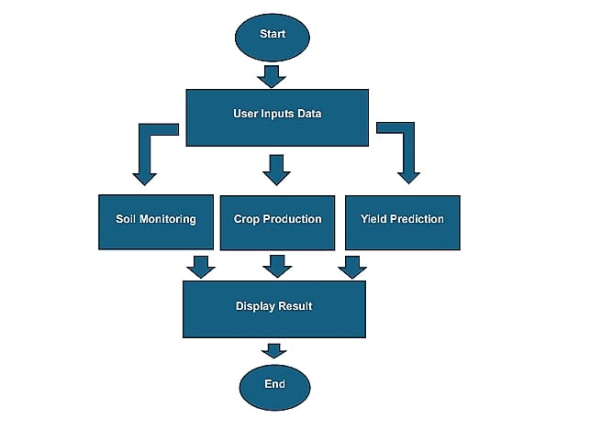

**Fig.4.2.1 Shows the workflow of the project**

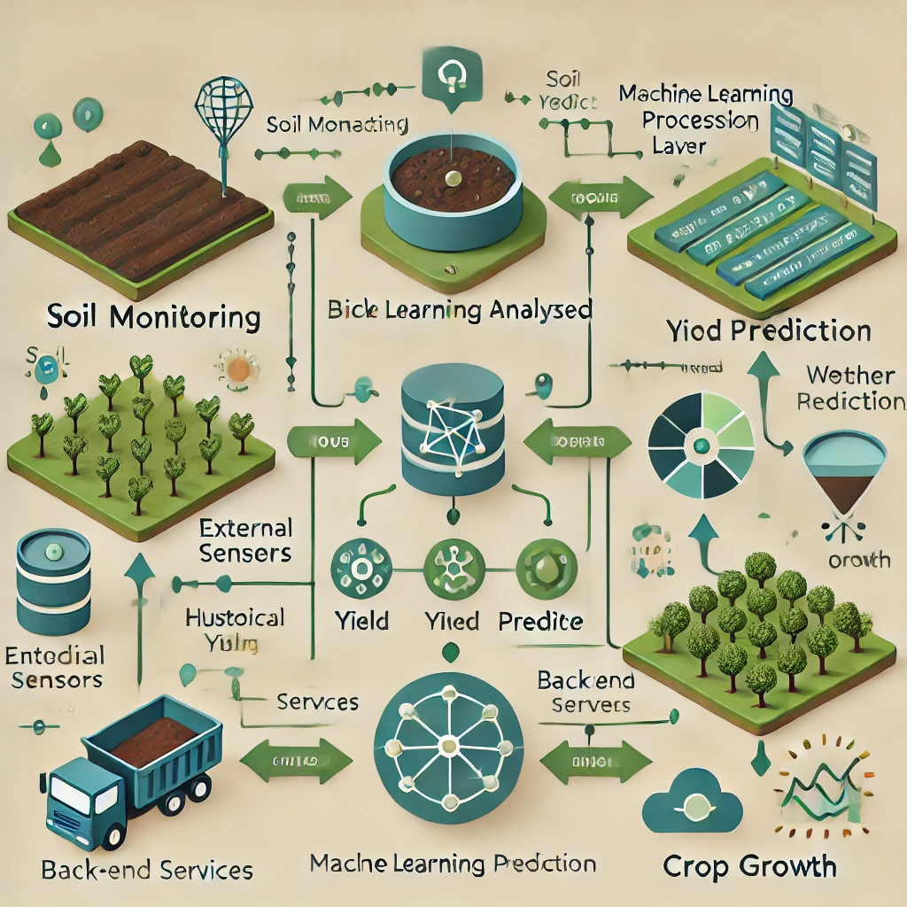

**Fig.4.2.2 Shows working of crop growth and production**

# 5.CONCLUSION & FUTURE WORK

#### 5.1 Conclusion

The "Yield Prediction Using Soil and Weather Data" project represents a significant step forward in leveraging modern technology to address the challenges faced by the agricultural sector. By integrating IoT sensors and machine learning, this system offers a powerful tool for farmers and agricultural stakeholders to make informed decisions that optimize resource usage, improve crop productivity, and promote sustainable farming practices. The real-time data collected from IoT sensors, combined with advanced predictive modeling, enables more accurate yield forecasts, helping farmers mitigate risks associated with unpredictable weather patterns, soil degradation, and other environmental factors.

Through this project, the potential for using data-driven insights to support agricultural decision-making becomes evident. It paves the way for improved efficiency in farming operations, reducing waste and maximizing the effectiveness of inputs like water, fertilizers, and labor. Furthermore, the system’s ability to continuously refine its predictions with new data ensures its relevance and adaptability in an ever-changing agricultural landscape.

##### **5.2 Future Work**

While the current project lays a solid foundation for yield prediction using soil and weather data, there are several directions for future enhancement and expansion:

1. **Integration of Additional Data Sources:**
   * The system can be enhanced by integrating satellite imagery, drone data, and remote sensing technologies. This would provide a more comprehensive understanding of crop health, growth patterns, and environmental conditions, improving the accuracy of yield predictions.
2. **Incorporating Machine Learning Advancements:**
   * As machine learning techniques evolve, the integration of more advanced models, such as deep learning and reinforcement learning, could improve prediction accuracy even further. The system could also utilize adaptive learning techniques that automatically adjust to new trends and conditions in real-time.
3. **Multi-Crop and Multi-Region Scalability:**
   * The system can be expanded to predict yields for a variety of crops in different geographical regions, each with its unique environmental and soil characteristics. This scalability will make the system more versatile and applicable to a wide range of agricultural contexts globally.
4. **Real-Time Weather Forecasting Integration:**
   * Integrating real-time weather forecasting data into the system could improve prediction accuracy by enabling the model to account for short-term weather changes and their potential impact on crop growth.
5. **User Training and Community Engagement:**
   * As the system is rolled out, it will be important to provide training to farmers and agricultural stakeholders on how to use the system effectively. This will ensure that users can make the most of the system’s capabilities and incorporate the predictions into their daily decision-making.
6. **Automated Resource Management:**
   * In the future, the system could be enhanced with an automated resource management feature that provides actionable suggestions for irrigation, fertilization, and pest control, potentially integrating with smart farming equipment for automated implementation.
7. **Data Security and Privacy:**
   * As the system collects vast amounts of data, particularly from multiple users, it is crucial to prioritize data security and privacy. Future work will involve developing robust encryption protocols and ensuring compliance with data protection regulations to safeguard user data.
8. **Climate Change Adaptation Models:**
   * With the ongoing changes in global climate patterns, it will be important to continuously adapt the prediction models to account for long-term shifts in temperature, precipitation, and other factors due to climate change. This will ensure the system remains useful in the face of evolving environmental conditions.

In conclusion, the proposed system has the potential to revolutionize yield prediction in agriculture, offering a data-driven, real-time solution for improving crop management and sustainability. By addressing the challenges faced by modern farmers and expanding the system’s capabilities, it can contribute to more efficient, resilient, and productive farming practices worldwide.

## **References**

**[1]** Zare, H., Weber, T. K. D., Ingwersen, J., Nowak, W., Gayler, S., & Streck, T. (2024). Within-season crop yield prediction by a multi-model ensemble with integrated data assimilation. Field Crops Research, 308, 109293.

**[2]** Akhter, R., & Sofi, S. A. (2022). Precision agriculture using IoT data analytics and machine learning. Journal of King Saud University – Computer and Information Sciences, 34, 5602-5618.

**[3]** Alahmad, T., Neményi, M., & Nyéki, A. (2023). Applying IoT sensors and big data to improve precision crop production: A review. Agronomy, 13(10), 2603.

**[4]** Alazzai, W. K., Abood, B. Sh. Z., Al-Jawahry, H. M., & Obaid, M. K. (2024). Precision farming: The power of AI and IoT technologies. E3S Web of Conferences, 491, 04006.

**[5]** Alazzai, W. K., Abood, B. Sh. Z., Al-Jawahry, H. M., & Obaid, M. K. (2024). Precision Farming: The Power of AI and IoT Technologies. E3S Web of Conferences, ICECS’24, 491, 04006. https://doi.org/10.1051/e3sconf/202449104006

**[7]** Tripathy, S., & Patra, S. (2020). IoT-Based Precision Agriculture System: A Review. In Smart Farming Technologies for Sustainable Agricultural Development (pp. 1-20). IGI Global. https://doi.org/10.4018/978-1-5225-9004-0.ch001

**[8]** Mahesh, P., & Soundrapandiyan, R. (2024). Yield Prediction for Crops by Gradient-Based Algorithms. PLOS ONE, 19(8), e0291928. https://doi.org/10.1371/journal.pone.0291928

**[9]** Kheir, A. M. S., Govind, A., Nangia, V., Devkota, M., Elnashar, A., Omar, M. E., & Feike, T. (2024). Developing automated machine learning approach for fast and robust crop yield prediction using a fusion of remote sensing, soil, and weather dataset. Environmental Research Communications, 6(041005).

**[10]** Athesan, A. I., & Mohd Ghazi, M. F. E. (2024). Innovative dashboard designs for real-time smart farming data visualization. National Engitech Digest, 1(1), 28-31.

**[12]** Javaid, M., Haleem, A., Khan, I. H., & Suman, R. (2023). Understanding the potential applications of artificial intelligence in the agriculture sector. Advanced Agrochem, 2, 15-30.

**[13]** Li, W., & He, W. (2024). Revenue-increasing effect of rural e-commerce: A perspective of farmers' market integration and employment growth. Economic Analysis and Policy, 81, 482-493.

**[14]** Karthika, S., Sharon, B. M., & Prince, S. P. M. (2023). Smart agriculture with IoT. International Journal of Innovative Research in Information Security, 9(3), 225-228.

**[15]** Jeffrey, L., & Bommu, R. (2024). Innovative AI Solutions for Agriculture: Enhancing Crop Management and Yield. International Journal of Advanced Engineering Technologies and Innovations, 1(3), 203–211.

**[16]** Mohyuddin, G., Khan, M. A., Haseeb, A., Mahpara, S., Waseem, M., & Saleh, A. M. (2024). Evaluation of Machine Learning Approaches for Precision Farming in Smart Agriculture System: A Comprehensive Review. IEEE Access, 12, 60155–60163. Najdenko, E., Lorenz, F., Dittert, K., & Olfs, H.-W. (2024). Rapid in-field soil analysis of plant-available nutrients and pH for precision agriculture—a review. Precision Agriculture, 25, 457–476. <https://doi.org/10.1007/s11119-024-09715-7>

**[17]** Kushwaha, M., Singh, S., Singh, V., & Dwivedi, S. (2024). Precision Farming: A Review of Methods, Technologies, and Future Prospects. International Journal of Environment, Agriculture and Biotechnology, 9(2).

**[18]** Ghazal, S., Munir, A., & Qureshi, W. S. (2024). Computer Vision in Smart Agriculture and Precision Farming: Techniques and Applications. Artificial Intelligence in Agriculture, 13, 64–83.

**[19]** Sobirovich, K. B. (2023). Conservation Agriculture for Increased Yields, Improved Soil Health, and Environmental Protection. Academic Research in Modern Science: International Scientific-Online Conference.

**[20]** Sharma, A., Jain, A., Gupta, P., & Chowdary, V. (2021). Machine Learning Applications for Precision Agriculture: A Comprehensive Review. IEEE Access, 9, 4843-4858. https://doi.org/10.1109/ACCESS.2020.3048415

**[21]** Adeniyi, J. K., Adeniyi, T. T., Ajagbe, S. A., Adeniyi, E. A., Aiyeniko, O., & Adigun, M. O. (2024). A Comparative Analysis of the Performance of Deep Learning Techniques in Precision Farming Using Soil and Climate Factors. Procedia Computer Science, 235, 2812-2821. https://doi.org/10.1016/j.procs.2024.04.266